Day 1 Leetcode

**Two Sum**

­Code

class Solution {

public int[] twoSum(int[] nums, int target) {

int[] ans = new int[2];

Map<Integer, Integer> map = new HashMap<>();

for(int i = 0; i < nums.length; i++){

if(map.containsKey(target - nums[i])) {

ans[0] = i;

ans[1] = map.get(target-nums[i]);

return ans;

}

else {

map.put(nums[i], i);

}

}

return ans;

}

}

Output

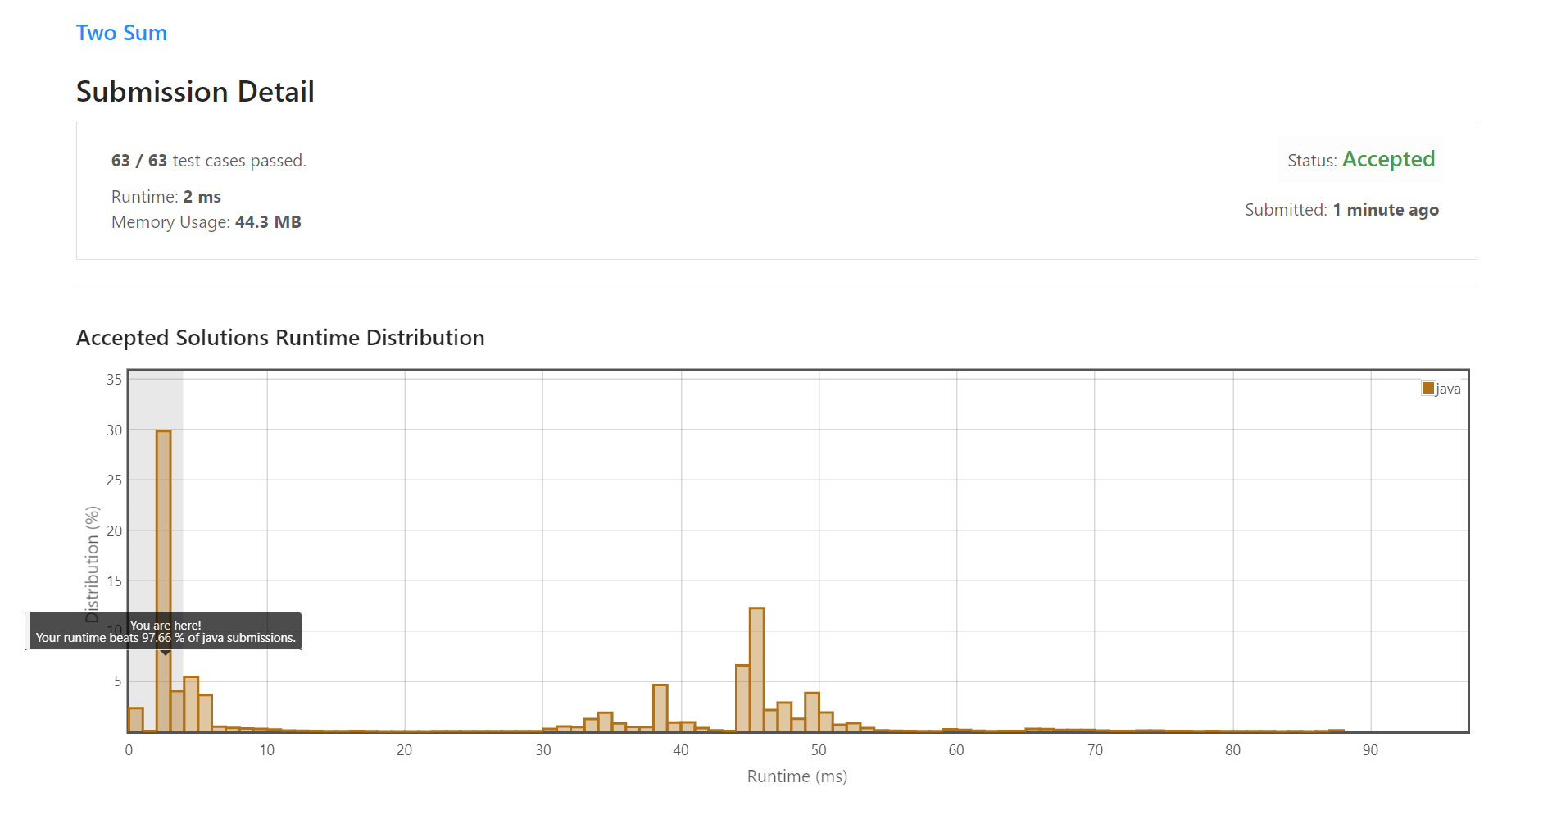

**Palindrome Number**

­Code

class Solution {

public boolean isPalindrome(int x) {

int r, sum = 0, temp;

temp = x;

while(x > 0) {

r = x % 10;

sum = (sum * 10) + r;

x = x / 10;

}

if(temp == sum) return true;

return false;

}

Output

